**Volunteer profile**

1. Basic information of a volunteer. For the registration status, there are pending status for those who are registered into TEAM, but not as a volunteer. Now we have closed the team sign up function.

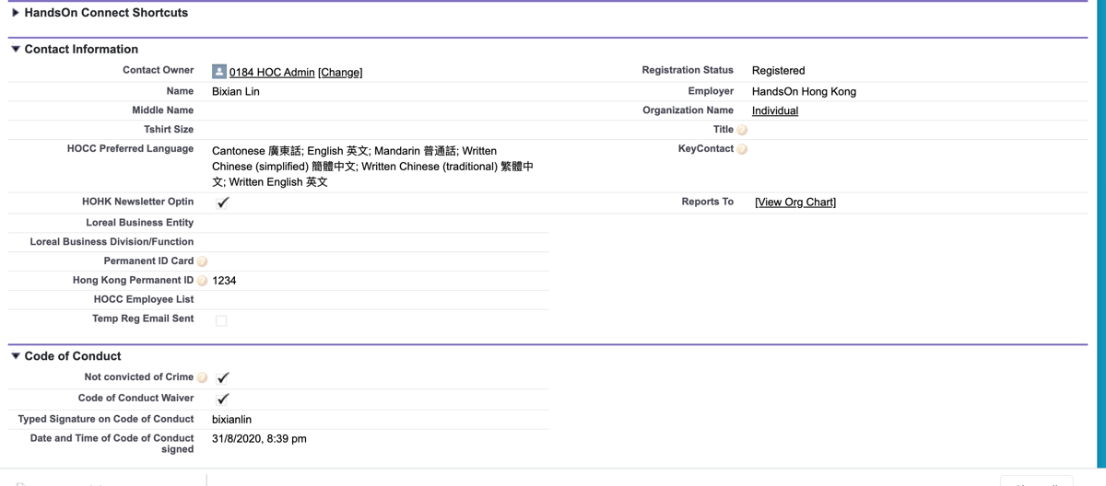

1. Contact information and other details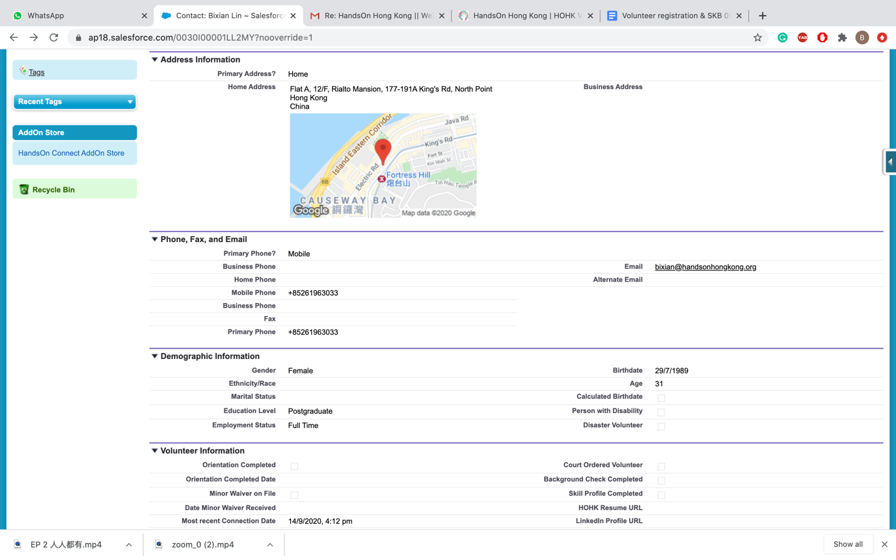
2. Pre-requisite sessions are the training sessions that we require volunteers to attend to before joining the services. We also encourage volunteers to input their interest for our future research or engagement:

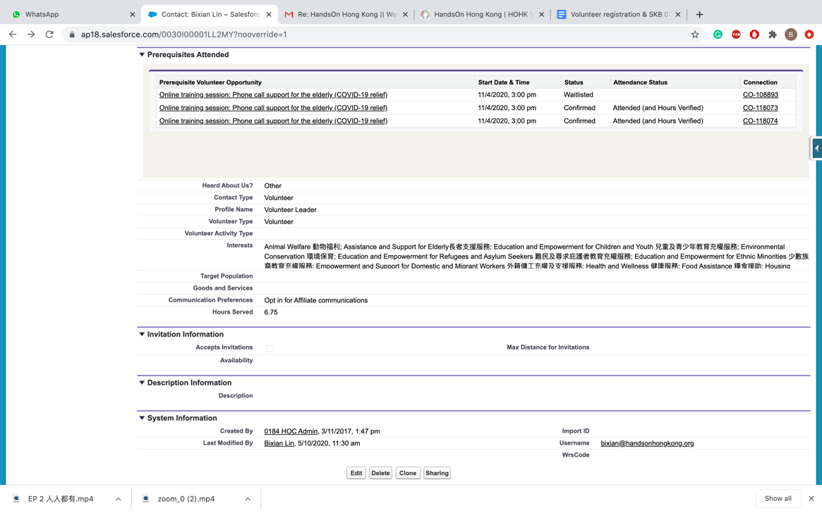

Please see here for the interest categories:

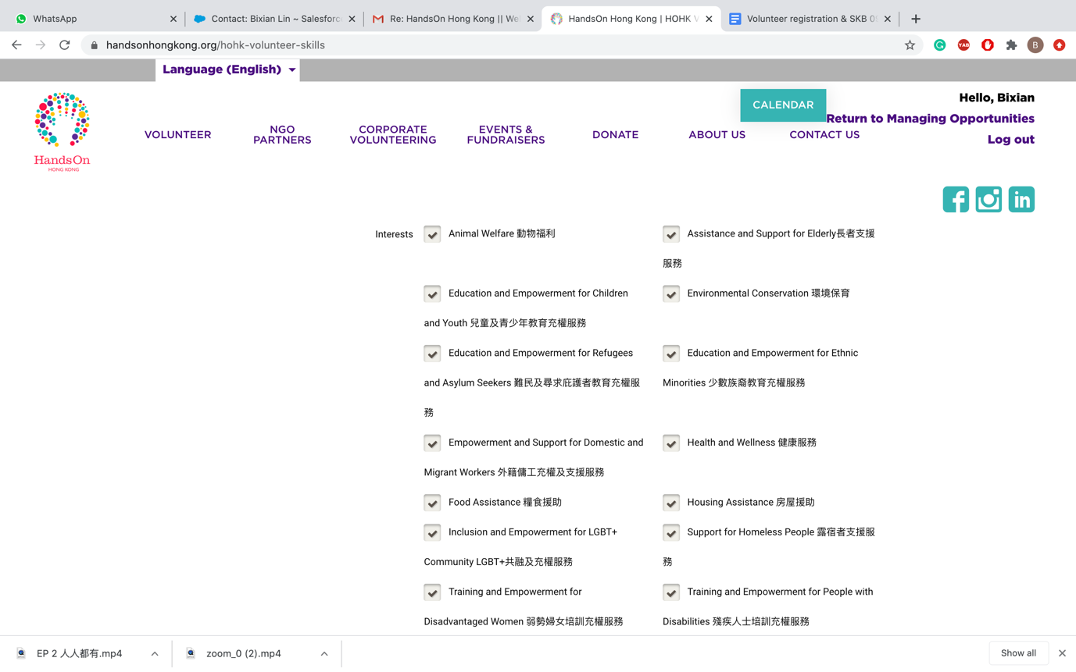

1. Volunteering history (Connection): dates, opportunity names, hours…

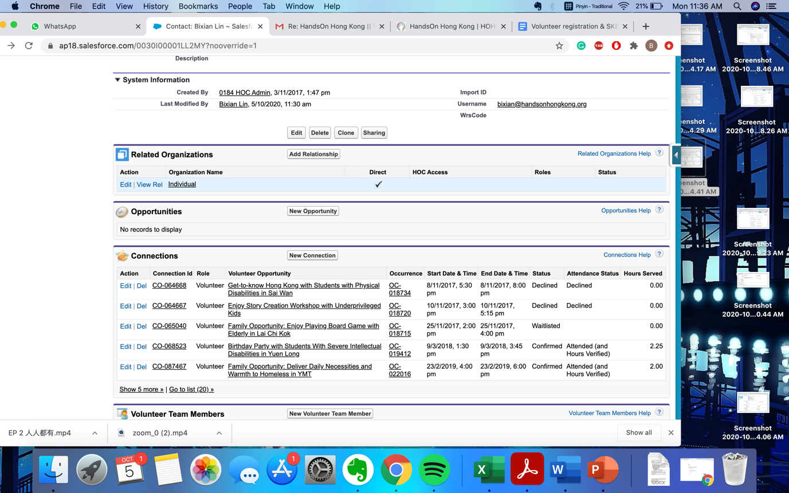

1. Following the information of previous volunteering history, it’s the section of skills of volunteers:

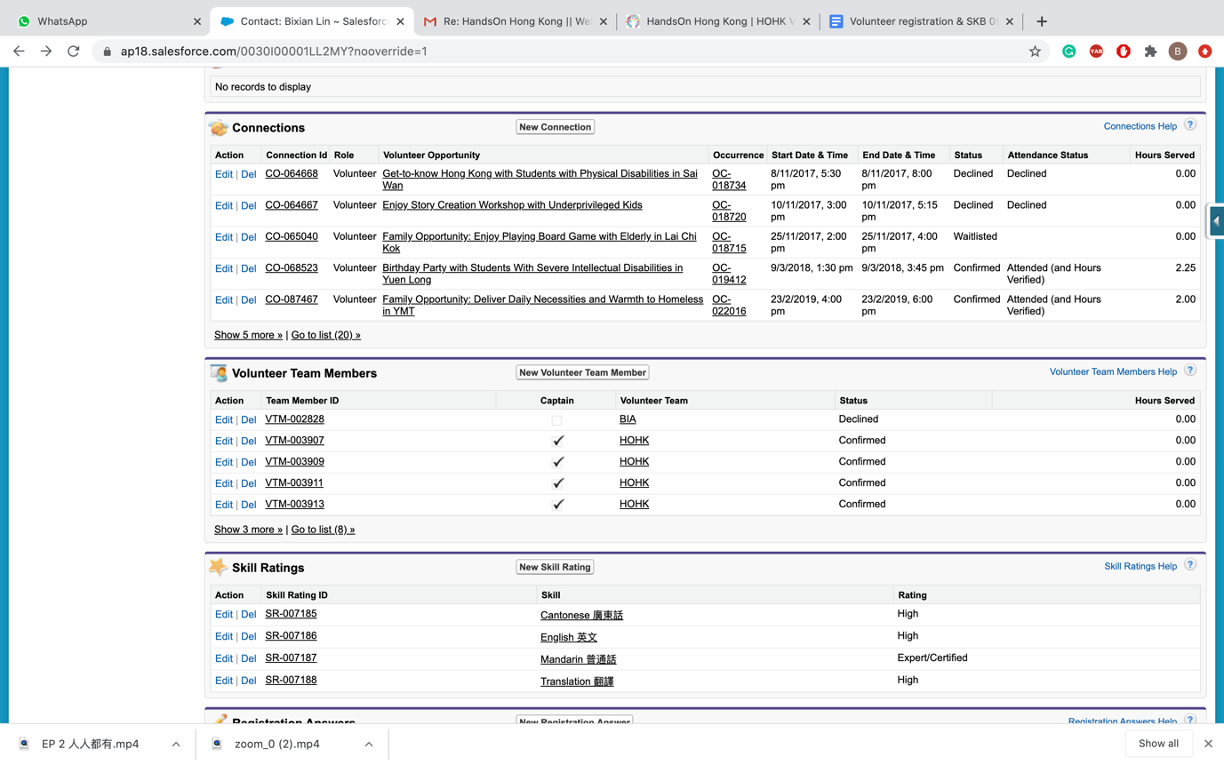

We are still working on update the skills from Language skills to job-related skills , here are the categories once we finished the update:

